Name: Avaneesh Pillay Roll No:45_B3
Practical 8
Aim: Implement Graph Colouring algorithm use Graph colouring concept.
Problem Statement:
A GSM is a cellular network with its entire geographical range divided into
hexadecimal cells. Each cell has a communication tower which connects with mobile
phones within cell. Assume this GSM network operates in different frequency
ranges. Allot frequencies to each cell such that no adjacent cells have same
frequency range.
Consider an undirected graph G = (V, E) shown in fig. Find the colour assigned to each
node
using Backtracking method. Input is the adjacency matrix of a graph G(V, E), where V is
the
number of Vertices and E is the number of edges..
Code:
#include <stdio.h>
#define MAX 10
int n;
int graph[MAX][MAX];
int colors[MAX];
int totalSolutions = 0;
int max_colors;
int isValid(int vertex, int color) {
for (int i = 0; i < n; i++) {
if (graph[vertex][i] == 1 && colors[i] == color)
return 0;
}
return 1;
}
void colorGraph(int vertex) {
if (vertex == n) {
totalSolutions++;
printf("Solution %d: ", totalSolutions);
for (int i = 0; i < n; i++)
printf("V%d->C%d ", i + 1, colors[i]);
printf("\n");
return;
}
for (int c = 1; c <= max_colors; c++) {
if (isValid(vertex, c)) {
colors[vertex] = c;
colorGraph(vertex + 1);
colors[vertex] = 0;
}
}
}
int main() {
n = 6;
max_colors = 3;
int temp[6][6] = {
{0, 1, 1, 0, 1, 1},
{1, 0, 1, 0, 0, 0},
{1, 1, 0, 1, 0, 0},
{0, 0, 1, 0, 1, 0},
{1, 0, 0, 1, 0, 1},
{1, 0, 0, 0, 1, 0}
};
for (int i = 0; i < n; i++)
for (int j = 0; j < n; j++)
graph[i][j] = temp[i][j];
for (int i = 0; i < n; i++)
colors[i] = 0;
printf("Graph Coloring using Backtracking\n");
printf("---------------------------------\n");
colorGraph(0);
if (totalSolutions == 0)
printf("No valid color assignment possible.\n");
else
printf("\nTotal Valid Combinations: %d\n", totalSolutions);
return 0;
}

Output:
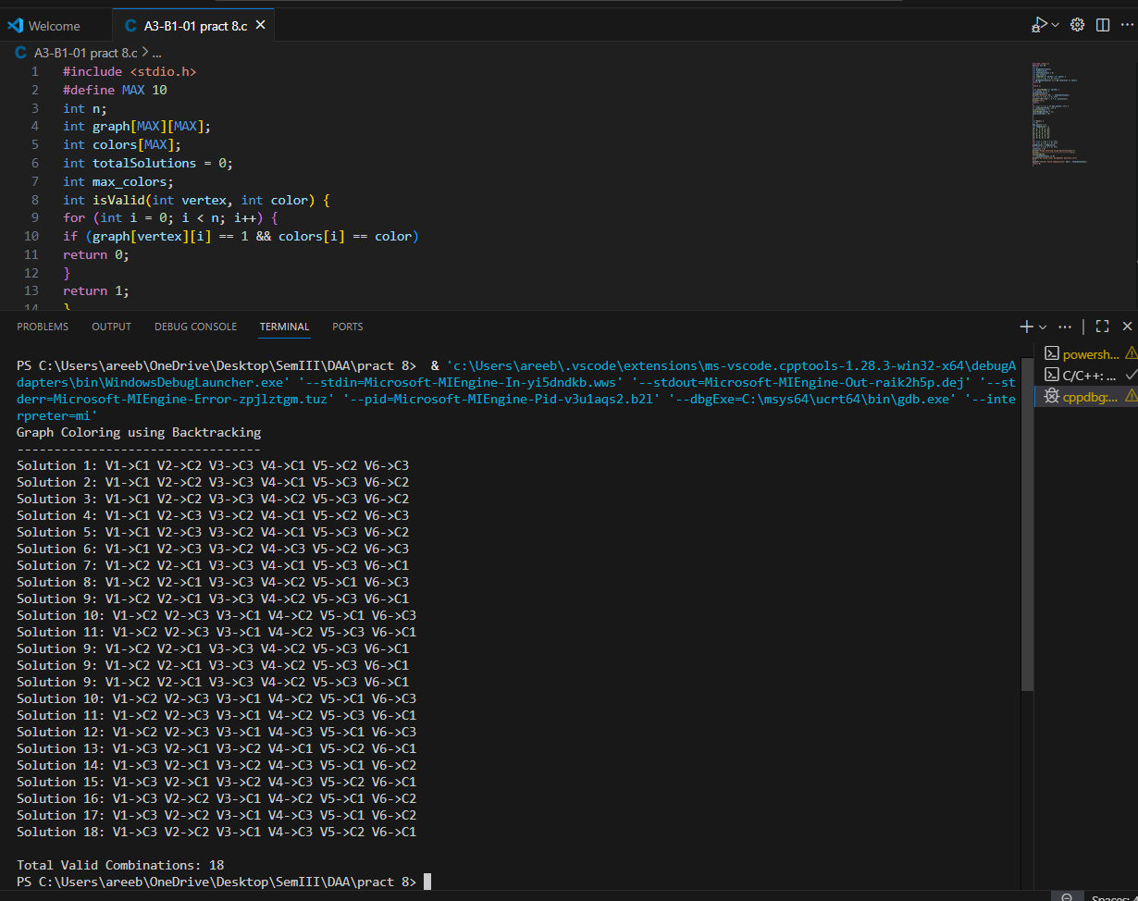
Link:
